

《程序设计课程实践》设计文档

第七章 第1次作业

学号：陈守炼 王天锜
姓名： 24050533

完成时间 2025 年 3 月

1、题目

2、小组成员分工
学号 | 姓名 | 完成工作 | 工作量占比
23070125 | 陈守炼 | 蛇的颜色，不同食物，排行榜 | 60%
24050533 | 王天锜 | 蛇断尾，障碍物，加减速 | 40%
备注：小组长写在第一行

3、程序设计思路
（1）存储蛇的每一个节点，如果蛇头的坐标与蛇身中的坐标有相同的，则从该点开始，减少蛇的长度，直到蛇尾
（2）类比PrintFood（）函数，增加一个PrintBarrier（）函数，随机生成障碍物并用结构体存储其坐标，后续用作死亡判断。
（3）增加unknow_food变量表示不同的事物，通过选择结构，展示出不同的事物对应不同的分数以及对蛇的影响
（4）利用文本文件，储存每一轮的分数，借助文本文件进行排序和输出。

4、程序源码
(1) snake.c
#include "snake.h"
/*全局变量定义*/
Snake snake1 = {.length = 6, .speed = 250, .snake_head = '@', .snake_body = 'o', .x = 1, .Dir = RIGHT};
Snake snake2 = {.length = 6, .speed = 250, .snake_head = '@', .snake_body = 'o', .x = 1, .Dir = RIGHT};
Food foods[MAX_FOOD]; // 定义食物结构体变量
Barrier barriers[MAX_BARRIER]; // 定义障碍物结构体变量
int foodCount = 1;
int barrierCount = 1;
char direction1 = RIGHT; // 预期蛇头方向
char direction2 = RIGHT;
Data data[100]; // 用户记录

const double updateInterval = 10.0; // 每 10 秒增加一次

/*主菜单实现*/
int Menu()
{
GotoXY(40, 12); // 定位光标位置
printf("欢迎来到贪吃蛇小游戏");
GotoXY(43, 14);
printf("1.开始游戏");
GotoXY(43, 16);
printf("2.帮助");
GotoXY(43, 18);
printf("3.关于");
GotoXY(43, 20);
printf("4.排行榜");
GotoXY(43, 22);
printf("其他任意键退出游戏");

Hide(); // 隐藏光标
char ch;
int result = 0;
ch = _getch(); // 接收用户输入的菜单选项
switch (ch)
{ // 根据选项设置返回结果值
case '1':
result = 1;
break;
case '2':
result = 2;
break;
case '3':
result = 3;
break;
case '4':
result = 4;
break;
}
system("cls"); // 调用系统命令cls完成清屏操作
return result;
}

// 光标定位函数，将光标定位到(x,y)坐标位置
void GotoXY(int x, int y)
{
HANDLE hout;
COORD cor;
hout = GetStdHandle(STD_OUTPUT_HANDLE);
cor.X = x;
cor.Y = y;
SetConsoleCursorPosition(hout, cor);
}

/*隐藏光标*/
void Hide()
{
HANDLE hout = GetStdHandle(STD_OUTPUT_HANDLE);
CONSOLE_CURSOR_INFO cor_info = {1, 0};
SetConsoleCursorInfo(hout, &cor_info);
}

/*关于菜单实现*/
void About()
{
GotoXY(30, 12);
printf("杭州电子科技大学--程序设计综合实践案例");
GotoXY(43, 14);
printf("贪吃蛇-控制台游戏");
GotoXY(43, 16);
printf("按任意键返回上级菜单");
Hide(); // 隐藏光标
char ch = _getch();
system("cls");
}

/*帮助菜单实现*/
void Help()
{
GotoXY(40, 12);
printf("w 上");
GotoXY(40, 14);
printf("s 下");
GotoXY(40, 16);
printf("a 左");
GotoXY(40, 18);
printf("d 右");
GotoXY(40, 20);
printf("q 加速");
GotoXY(40, 22);
printf("e 减速");
GotoXY(50, 12);
printf("i 上");
GotoXY(50, 14);
printf("k 下");
GotoXY(50, 16);
printf("j 左");
GotoXY(50, 18);
printf("l 右");
GotoXY(50, 20);
printf("u 加速");
GotoXY(50, 22);
printf("o 减速");
GotoXY(44, 24);
printf("当蛇撞墙时游戏结束");
GotoXY(45, 26);
printf("按任意键返回上级菜单");
Hide(); // 隐藏光标
char ch = _getch();
system("cls");
}
void Init(int player, int AI)
{
if (player == 1)
{
InitMap(&snake1, player);

// if (AI) { AI 蛇,设计AI蛇的函数逻辑;AI蛇的结构体已经给出;

// }
}
else if (player == 2)
{
InitMap(&snake1, player);
InitMap(&snake2, player);
while (abs(snake2.snakeNode[0].x - snake1.snakeNode[0].x) < 4)
{
InitMap(&snake2, player);
}
// if (AI) { AI 蛇,设计AI蛇的函数逻辑;AI蛇的结构体已经给出;将对手作为AI
// }
}
};
void InitMap(Snake *snake, int player)
{
SetConsoleOutputCP(936);
Hide(); // 隐藏光标

// 设置蛇头位置随机生成
snake->snakeNode[0].x = (rand() % (MAP_WIDTH - 5)) + 4;
snake->snakeNode[0].y = (rand() % (MAP_HEIGHT - 2));
GotoXY(snake->snakeNode[0].x, snake->snakeNode[0].y); // 将光标移动到蛇头位置
SetColor(11);
printf("%c", snake->snake_head); // 打印蛇头
snake->Dir = RIGHT; // 当前蛇头方向
// 显示蛇身
for (int i = 1; i < snake->length; i++)
{
// 设置蛇身的纵坐标位置和蛇头位置相同
snake->snakeNode[i].y = snake->snakeNode[i - 1].y;
// 设置蛇身的横坐标位置，蛇身在蛇头的左边,所以横坐标依次减1
snake->snakeNode[i].x = snake->snakeNode[i - 1].x - 1;
GotoXY(snake->snakeNode[i].x, snake->snakeNode[i].y); // 移动光标到蛇身位置
SetColor(rand() % 14 + 2); // 随机设置颜色
printf("%c", snake->snake_body); // 打印蛇身
}
// 生成地图上下边界
Map();
PrintBarrier(snake);
PrintFood(snake);
// 生成食物和障碍物
// 得分说明
SetColor(15);
if (player == 1)
{
GotoXY(50, 5);
printf("当前得分:00");
GotoXY(50, 15);
printf(" 当前速度：慢速 ");
}
else
{
GotoXY(50, 5);
printf("当前得分:00");
GotoXY(50, 15);
printf(" 当前速度：慢速 ");
GotoXY(70, 5);
printf("当前得分:00");
GotoXY(70, 15);
printf(" 当前速度：慢速 ");
}
SpeedControl(snake); // 默认慢速
GotoXY(50, 15);
printf(" 当前速度：慢速 ");
GotoXY(50, 7);
printf("*为普通食物,吃到得1分");
GotoXY(50, 9);
printf("$为精华食物,吃到得2分");
GotoXY(50, 11);
printf("?为未知的食物，吃了可能加分，可能扣分，也可能中毒！");
GotoXY(50, 13);
printf("■为障碍物，撞到了会死亡！");
}
void AddFood()
{
if (foodCount >= MAX_FOOD)
return;

Food food;
// 设置随机的食物坐标位置
food.x = rand() % (MAP_WIDTH - 2) + 1;
food.y = rand() % (MAP_HEIGHT - 2) + 1;

foods[foodCount] = food;
foodCount++;
}
void PrintFood(Snake *snake)
{
int flag = 1;
for (int i = 0; i <= foodCount - 1; i++)
{
while (flag)
{
flag = 0;

// 循环判断食物位置是否和蛇的位置重叠，如果重叠则需要重新设置食物位置
for (int k = 0; k <= snake->length - 1; k++)
{
if (snake->snakeNode[k].x == foods[i].x && snake->snakeNode[k].y == foods[i].y)
{
foods[i].x = rand() % (MAP_WIDTH - 2) + 1;
foods[i].y = rand() % (MAP_HEIGHT - 2) + 1;
flag = 1; // 位置有重叠，需要继续循环
break;
}
}

if (foods[i].x == 0 || foods[i].y == 0 || foods[i].x == MAP_HEIGHT || foods[i].y == MAP_WIDTH)
{
foods[i].x = rand() % (MAP_WIDTH - 2) + 1;
foods[i].y = rand() % (MAP_HEIGHT - 2) + 1;
flag = 1; // 食物位置与边框位置存在重合
}
}
}
for (int i = 0; i <= foodCount - 1; i++)
{
GotoXY(foods[i].x, foods[i].y);
int nb = rand() % 3; // 选择随机生成的食物
if (nb == 0)
{
foods[i].score_food = 1;
SetColor(13);

printf("*"); // 普通食物
}
else if (nb == 1)
{
foods[i].score_food = 3;

SetColor(10);

printf("$"); // 精华食物
}
else if (nb == 2)
{
int sb = rand() % 10 + 1;
if (sb == 1)
{
foods[i].score_food = 0;
}
else if (sb >= 2 && sb <= 7)
{
foods[i].score_food = 3;
}
else
{
foods[i].score_food = -1;
}

SetColor(12);
printf("?"); // 未知的食物
}
}
}

int MoveSnake(Snake *snake, char direction, int player)
{
SetConsoleOutputCP(936);
Snakenode temp;
int flag = 0;
temp = snake->snakeNode[snake->length - 1]; // 记录蛇尾
for (int i = snake->length - 1; i >= 1; i--)
snake->snakeNode[i] = snake->snakeNode[i - 1]; // 将所有蛇身向前移动一个位置
GotoXY(snake->snakeNode[1].x, snake->snakeNode[1].y); // 原来蛇头位置为蛇身
SetColor(rand() % 14 + 2);
printf("%c", snake->snake_body); // 前进方向打印一节蛇身，其他蛇身不需要打印
clock_t currentTime = clock();
double elapsed = (double)(currentTime - lastUpdateTime) / CLOCKS_PER_SEC;
if (elapsed >= updateInterval)
{
AddBarrier();
AddFood();
lastUpdateTime = currentTime;
}
// 响应键盘修改
if (_kbhit())
{
// 键盘输入返回1，非键盘输入返回0
direction = _getch();
if (_kbhit())
{
char input = _getch();
if (input == UP_P1 || input == DOWN_P1 || input == LEFT_P1 || input == RIGHT_P1 ||
input == Speedup_P1 || input == Speeddown_P1 || input == Speedup_P1 || input == Speeddown_P1)
{
if (snake == &snake1)
direction = input;
}
else if (input == UP_P2 || input == DOWN_P2 || input == LEFT_P2 || input == RIGHT_P2 ||
input == Speedup_P2 || input == Speeddown_P2 || input == Speedup_P2 || input == Speeddown_P2)
{
if (snake == &snake2)
direction = input;
}
}

switch (direction)
{ // 因为每次只有一个键盘输入，所以和方向输入放一起了
case Speedup_P1:
case Speedup_P2:
snake->x = 1;
break; // 速度修改
case Speeddown_P1:
case Speeddown_P2:
snake->x = 2;
break;
default:
break;
}

switch (direction)
{
case UP_P1:
case UP_P2: // 按下w键
if (snake->Dir != DOWN) // 如果蛇头向下，按向上移动的键w时不起作用
snake->Dir = direction;
break;
case DOWN_P1:
case DOWN_P2: // 按下s键
if (snake->Dir != UP) // 如果蛇头向上，按向下移动的键s时不起作用
snake->Dir = direction;
break;
case LEFT_P1:
case LEFT_P2: // 按下a键
if (snake->Dir != RIGHT) // 如果蛇头向右，按向左移动的键a时不起作用
snake->Dir = direction;
break;
case RIGHT_P1:
case RIGHT_P2: // 按下d键
if (snake->Dir != LEFT) // 如果蛇头向左，按向右移动的键d时不起作用
snake->Dir = direction;
break;
}
}
switch (snake->Dir)
{ // 根据现在的方向修改蛇头的位置
case UP_P1:
case UP_P2: // 按下w键
snake->snakeNode[0].y--;
break; // 向上移动

case DOWN_P1:
case DOWN_P2: // 按下s键
snake->snakeNode[0].y++;
break; // 向下移动

case LEFT_P1:
case LEFT_P2: // 按下a键:
snake->snakeNode[0].x--;
break; // 向左移动
case RIGHT_P1:
case RIGHT_P2: // 按下d键
snake->snakeNode[0].x++;
break; // 向右移动
}
// 打印蛇头
GotoXY(snake->snakeNode[0].x, snake->snakeNode[0].y);
SetColor(11);
printf("%c", snake->snake_head);
if (!ThroughWall(snake))
{ // 如果撞墙，穿墙
if (snake->snakeNode[0].x < 1 || snake->snakeNode[0].x > MAP_WIDTH - 2)
{
if (snake->snakeNode[0].x < 1)
{
snake->snakeNode[0].x = MAP_WIDTH - 2;
}
else if (snake->snakeNode[0].x > MAP_WIDTH - 2)
{
snake->snakeNode[0].x = 1;
}
}
else if (snake->snakeNode[0].y > MAP_HEIGHT - 2 || snake->snakeNode[0].y < 1)
{
if (snake->snakeNode[0].y > MAP_HEIGHT - 2)
{
snake->snakeNode[0].y = 1;
}
else if (snake->snakeNode[0].y < 1)
{
snake->snakeNode[0].y = MAP_HEIGHT - 2;
}
}
}
// 判断是否吃到食物，如果蛇头的位置和食物的位置相同表示吃到食物
for (int i = 0; i < foodCount; i++)
{
if (snake->snakeNode[0].x == foods[i].x && snake->snakeNode[0].y == foods[i].y)
{
SetConsoleOutputCP(936);

if (snake->length + foods[i].score_food - 3 < 1 || foods[i].score_food == 0)
{

SetColor(15);
system("cls");
if (player == 1)
{
SetConsoleOutputCP(936);
GotoXY(45, 14);
printf("玩家1最终得分:%d", snake1.length - 3);
GotoXY(45, 16);
printf("中毒，你死了！");
GotoXY(45, 18);
printf("按任意键返回主菜单");
}
else
{
SetColor(15);
SetConsoleOutputCP(936);
GotoXY(45, 14);
printf("玩家1最终得分:%d", snake1.length - 3);
GotoXY(45, 16);
printf("玩家2最终得分:%d", snake2.length - 3);
GotoXY(45, 18);
printf("中毒，你死了！");
GotoXY(45, 20);
printf("按任意键返回主菜单");
}
char c = _getch();
system("cls");
return 0;
}
else if (foods[i].score_food == -1) // 吃到食物，但是-1
{
for (int k = 0; k < barrierCount - 1; k++)
{
GotoXY(barriers[k].x, barriers[k].y);
printf(" ");
}
GotoXY(temp.x, temp.y);
printf(" ");
GotoXY(snake->snakeNode[snake->length - 2].x, snake->snakeNode[snake->length - 2].y);
printf(" ");

snake->length--;
}
else
{
for (int k = 0; k < barrierCount - 1; k++)
{
GotoXY(barriers[k].x, barriers[k].y);
printf(" ");
}
snake->length += foods[i].score_food; // 吃到食物，蛇长增加
}
flag = 1; // flag为1表示吃到食物，为0表示没有吃到食物
snake->snakeNode[snake->length - 1] = temp; // 吃到食物，蛇尾加一节;实际上是蛇尾不变，蛇头发生了一个位置
}
}
// 输出蛇此时状态
// 没吃到食物时，在原来的蛇尾打印一个空格，去掉原来的蛇尾
if (!flag)
{
GotoXY(temp.x, temp.y);
printf(" ");
}
else
{
for (int k = 0; k < barrierCount - 1; k++)
{
GotoXY(barriers[k].x, barriers[k].y);
printf(" ");
}
PrintBarrier(snake);
PrintFood(snake);

// 吃到食物，才会更新障碍物,重新更新一个食物
if (player == 1)
{
GotoXY(50, 5);
printf("当前得分:%d", snake1.length - 3);
}
else
{ // 打印得分，得分为蛇长减原始长度3
GotoXY(50, 5);
printf("当前得分:%d", snake1.length - 3);
GotoXY(70, 5);
printf("当前得分:%d", snake2.length - 3);
}
}
// 判断是否死亡
if (!IsCorrect(snake))
{ // 如果撞障碍物，则清除屏幕，打印最终得分，游戏结束

SetConsoleOutputCP(936);
SetConsoleCP(936);
SetColor(15);
system("cls");

if (player == 1)
{
SetConsoleOutputCP(936);
GotoXY(45, 14);
printf("最终得分：%d", snake1.length - 3);
GotoXY(45, 16);
printf("你输了！");
GotoXY(45, 18);
printf("按任意键返回主菜单");
}
else
{
SetConsoleOutputCP(936);
GotoXY(45, 14);
printf("玩家1最终得分:%d", snake1.length - 3);
GotoXY(45, 16);
printf("玩家2最终得分:%d", snake2.length - 3);
GotoXY(45, 18);
printf("你输了！");
GotoXY(45, 20);
printf("按任意键返回主菜单");
}
char c = _getch();
system("cls");
return 0;
}

Map();
if (Overlap(snake)) // 判断是否自撞
{
int t = snake->length;
for (int j = Overlap(snake) + 1; j < t; j++)
{
GotoXY(snake->snakeNode[j].x, snake->snakeNode[j].y);
printf(" ");
snake->length -= 1;
}
if (player == 1)
{
GotoXY(50, 5);
printf("当前得分:%d", snake1.length - 3);
}
else
{ // 打印得分，得分为蛇长减原始长度3
GotoXY(50, 5);
printf("当前得分:%d", snake1.length - 3);
GotoXY(70, 5);
printf("当前得分:%d", snake2.length - 3);
}
}
if (snake->x == 1) // 调整速度

{
SpeedControl(snake); // 慢速
if (player == 1)
{
GotoXY(50, 15);
printf(" 当前速度：慢速 ");
}
else
{
{
if (snake1.x == 1)
{
GotoXY(50, 15);
printf(" 当前速度：慢速 ");

} // 慢速
else if (snake2.x == 1)
{
GotoXY(70, 15);
printf(" 当前速度：慢速 ");
}
}
}
}
else if (snake->x == 2)
{
if (player == 1)
{
GotoXY(50, 15);
printf(" 当前速度：快速 ");
}
else
{
if (snake1.x == 2)
{
GotoXY(50, 15);
printf(" 当前速度:快速 ");
}
else if (snake2.x == 2)
{
GotoXY(70, 15);
printf(" 当前速度:快速 ");
}
}
}
Sleep(snake->speed); // 把进程挂起一段时间，用于控制蛇移动的速度
return 1;
}

/*判断是否自撞或撞墙,返回值为0表示自撞或撞墙，否则为1*/

int IsCorrect(Snake *snake)
{
for (int k = 0; k < barrierCount - 1; k++)
{
if (snake->snakeNode[0].x == barriers[k].x && snake->snakeNode[0].y == barriers[k].y || snake->snakeNode[0].x == barriers[k].x + 1 && snake->snakeNode[0].y == barriers[k].y + 1) // 判断蛇头是否撞墙
return 0;
}

return 1;
}
int ThroughWall(Snake *snake)
{
if (snake->snakeNode[0].x == 0 || snake->snakeNode[0].y == 0 || snake->snakeNode[0].x == MAP_WIDTH - 1 || snake->snakeNode[0].y == MAP_HEIGHT - 1) // 判断蛇头是否撞墙
return 0;
return 1;
}

/*判断是否碰到蛇身*/

int Overlap(Snake *snake)
{
for (int i = 1; i < snake->length; i++)
{ // 判断蛇头是否和蛇身重叠，重叠表示自撞
if (snake->snakeNode[0].x == snake->snakeNode[i].x && snake->snakeNode[0].y == snake->snakeNode[i].y)
{
return i;
}
}
return 0;
}

/*生成地图函数*/
void Map()
{
// SetColor(rand() % 10 + 2); 则随机改变边框颜色
for (int i = 0; i < MAP_WIDTH; i++)
{
GotoXY(i, 0);
printf("-");
GotoXY(i, MAP_HEIGHT - 1);
printf("-");
}
// 生成地图左右边界
for (int i = 1; i < MAP_HEIGHT - 1; i++)
{
GotoXY(0, i);
printf("|");
GotoXY(MAP_WIDTH - 1, i);
printf("|");
}
}
/*慢速调整函数*/

void SpeedControl(Snake *snake)
{
switch (snake->length)
{ // 根据蛇长调整蛇的移动速度
case 8:
snake->speed = 220;
break;
case 12:
snake->speed = 205;
break;
case 14:
snake->speed = 190;
break;
case 17:
snake->speed = 185;
break;
case 20:
snake->speed = 170;
break;
case 23:
snake->speed = 150;
break;
case 26:
snake->speed = 130;
break;
case 30:
snake->speed = 110;
break;
case 33:
snake->speed = 80;
break;
default:
break;
}
}

void SpeedControl2(Snake *snake)
{
switch (snake->length)
{ // 根据蛇长调整蛇的移动速度
case 8:
snake->speed = 115;
break;
case 12:
snake->speed = 110;
break;
case 14:
snake->speed = 105;
break;
case 17:
snake->speed = 100;
break;
case 20:
snake->speed = 95;
break;
case 23:
snake->speed = 90;
break;
case 26:
snake->speed = 70;
break;
case 30:
snake->speed = 50;
break;
case 33:
snake->speed = 20;
break;
default:
break;
}
}
void Read()
{
FILE *file;
file = fopen("scores.txt", "rb");
fscanf(file, "%d", &data[0].count);
for (int i = 0; i < data[0].count; i++)
{
fscanf(file, "%s", &data[i].name);
fscanf(file, "%d", &data[i].score);
data[i].count = data[0].count;
}
fclose(file);
}

void List()
{
SetConsoleOutputCP(936);
GotoXY(48, 12);
printf("用户名");
GotoXY(58, 12);
printf("分数");
int i;
for (i = 0; i < 3; i++)
{
GotoXY(48, 12 + (i + 1) * 2);
printf("%s", data[i].name);
GotoXY(58, 12 + (i + 1) * 2);
printf("%d", data[i].score);
}
GotoXY(48, 12 + (i + 1) * 2);
printf("按任意键返回菜单");
Hide();
char ch = _getch();
system("cls");
}

void Name(int x)
{
SetConsoleOutputCP(936);
if (x == 1)
{
SetConsoleOutputCP(936);
GotoXY(48, 12);
printf("请输入用户名：");
GotoXY(48, 14);
scanf("%s", &data[data[0].count].name);
}
else if (x == 2)
{
SetConsoleOutputCP(936);
GotoXY(48, 12);
printf("请输入用户名1:");
GotoXY(48, 14);
scanf("%s", &data[data[0].count].name);
data[0].count++;
system("cls");
GotoXY(48, 12);
SetConsoleOutputCP(936);
printf("请输入用户名2:");
GotoXY(48, 14);
scanf("%s", &data[data[0].count].name);
}
data[0].count++;
system("cls");
}

void Rank()
{
int max_index;
char a[50];

for (int i = 0; i < data[0].count; i++) // 选择排序
{
max_index = i;
for (int j = i + 1; j < data[0].count; j++)
{
if (data[j].score > data[i].score)
{
max_index = j;
}
}
strcpy(a, data[i].name);
strcpy(data[i].name, data[max_index].name);
strcpy(data[max_index].name, a);
int temp = data[i].score;
data[i].score = data[max_index].score;
data[max_index].score = temp;
}
List();
}

void Write()
{
FILE *file;
file = fopen("scores.txt", "wb");
fprintf(file, "%d\n", data[0].count);
for (int i = 0; i < data[0].count; i++)
{
fprintf(file, "%s ", data[i].name);
fprintf(file, "%d", data[i].score);
fprintf(file, "\n");
}
fclose(file);
}

void SetColor(int c)
{
// 颜色设置
SetConsoleTextAttribute(GetStdHandle(STD_OUTPUT_HANDLE), c);
}

void AddBarrier()
{
Barrier barrier;
barrier.x = rand() % (MAP_WIDTH - 2) + 1;
barrier.y = rand() % (MAP_HEIGHT - 2) + 1;

barriers[barrierCount] = barrier;
barrierCount++;
}
/*生成障碍物函数*/
void PrintBarrier(Snake *snake)
{
int flag = 1;
for (int i = 0; i <= barrierCount - 1; i++)
{
while (flag)
{
flag = 0;

// 循环判断障碍物位置是否和蛇的位置重叠，如果重叠则需要重新设置食物位置
for (int k = 0; k <= snake->length - 1; k++)
{
if (snake->snakeNode[k].x == barriers[i].x && snake->snakeNode[k].y == barriers[i].y)
{
barriers[i].x = rand() % (MAP_WIDTH - 2) + 1;
barriers[i].y = rand() % (MAP_HEIGHT - 2) + 1;
flag = 1; // 位置有重叠，需要继续循环
break;
}
}
for (int k = 0; k <= foodCount - 1; k++)
{
if (foods[k].x == barriers[i].x && foods[k].y == barriers[i].y)
{
barriers[i].x = rand() % (MAP_WIDTH - 2) + 1;
barriers[i].y = rand() % (MAP_HEIGHT - 2) + 1;
flag = 1; // 位置有重叠，需要继续循环
break;
}
}
if (barriers[i].x == 0 || barriers[i].y == 0 || barriers[i].x == MAP_HEIGHT || barriers[i].y == MAP_WIDTH)
{
barriers[i].x = rand() % (MAP_WIDTH - 2) + 1;
barriers[i].y = rand() % (MAP_HEIGHT - 2) + 1;
flag = 1; // 位置有重叠，需要继续循环
}
}
}
for (int i = 0; i <= barrierCount - 1; i++)
{
GotoXY(barriers[i].x, barriers[i].y);
printf("■");
}
}
int Mode()
{
SetConsoleOutputCP(936);
GotoXY(40, 12); // 定位光标位置
printf("选择难度模式");
GotoXY(43, 14);
printf("1.普通模式");
GotoXY(43, 16);
printf("2.困难模式");

char ch;
int result = 0;
ch = _getch(); // 接收用户输入的菜单选项
switch (ch)
{
case '1':
result = 1;
break;

case '2':
result = 2;
break;
}
system("cls");
return result;
}
int Player_Mode()
{
SetConsoleOutputCP(936);
GotoXY(40, 12); // 定位光标位置
printf("选择玩家模式");
GotoXY(43, 14);
printf("1.单人模式");
GotoXY(43, 16);
printf("2.双人模式");

char ch;
int result = 0;
ch = _getch(); // 接收用户输入的菜单选项
switch (ch)
{
case '1':
result = 1;
break;

case '2':
result = 2;
break;
}
system("cls");
return result;
}
int Enable_AI()
{
SetConsoleOutputCP(936);
GotoXY(40, 12); // 定位光标位置
printf("选择是否启用AI");
GotoXY(43, 14);
printf("1.启用AI");
GotoXY(43, 16);
printf("2.不启用AI");

char ch;
int result = 0;
ch = _getch(); // 接收用户输入的菜单选项
switch (ch)
{
case '1':
result = 1;
break;

case '2':
result = 2;
break;
}
system("cls");
return result;
} (2) snake.h
/*引入必要的头文件*/
#include <stdio.h>
#include <Windows.h>
#include <conio.h>
#include <time.h>
#include <locale.h>
#include <wchar.h>

/*MCIERROR mciSendString(
LPCTSTR lpszCommand, //命令字符串：如 open、play 、close等
LPTSTR lpszReturnString, //接受返回信息的字符串 ，即字符串
UINT cchReturn, //返回字符串的大小，sizeof
HANDLE hwndCallback //回调窗口句柄，一般设置为NULL
) */

/*宏定义*/
#define MAP_HEIGHT 20 // 定义地图高度
#define MAP_WIDTH 40 // 定义地图宽度
#define UP_P1 'w' // 定义上移键
#define DOWN_P1 's' // 定义下移键
#define LEFT_P1 'a' // 定义左移键
#define RIGHT_P1 'd' // 定义右移键
#define Speedup_P1 'q' // 定义加速键
#define Speeddown_P1 'e' // 定义减速键
#define UP_P2 'i' // 定义上移键
#define DOWN_P2 'k' // 定义下移键
#define LEFT_P2 'j' // 定义左移键
#define RIGHT_P2 'l' // 定义右移键
#define Speedup_P2 'u' // 定义加速键
#define Speeddown_P2 'o' // 定义减速键
#define MAX_FOOD 10
#define MAX_BARRIER 10

/*结构体定义*/
typedef struct Point // 定义食物、障碍物和蛇位置的结构体
{
int x; // x坐标位置
int y; // y坐标位置
} Barrier, Snakenode;
typedef struct {
int x;
int y;
int score_food;

} Food;
// 方向枚举
typedef enum
{
UP,
DOWN,
LEFT,
RIGHT
} Direction;
typedef struct // 定义蛇的结构体
{
Snakenode snakeNode[1000]; // 蛇长最多包含1000个节点
int length; // 蛇长度
int speed; // 蛇移动速度
char snake_head; // 蛇头字符
char snake_body; // 蛇身字符
int x; // 加减速
Direction Dir;

} Snake;
extern char direction1, direction2;
extern clock_t lastUpdateTime;
extern Snake snake1, snake2; // 这里要初始化// 定义蛇结构体变量,设置蛇长初始值为3节,设置蛇初始移动速度为250
// 你需要设计一个函数，将你自定义的蛇来代替默认的蛇；结构体已给出；
typedef struct
{
char name[100];
int score; // 分数
int count; // 用户数量
} Data;
extern Data data[100];
// typedef struct 定义AI蛇
// {
// } AI_snake;

/*函数定义*/
void GotoXY(int, int); // 光标定位函数
void Hide(); // 隐藏光标函数
int Menu(); // 主菜单函数
void Help(); // 帮助信息
void About(); // 关于信息
void InitMap(Snake *snake,int player); // 地图初始化
void PrintFood(Snake *snake); // 生成食物
void PrintBarrier(Snake *snake); // 生成障碍物
int MoveSnake(Snake *snake, char direction, int player); // 蛇移动
int IsCorrect(); // 自撞或撞墙检测
void SpeedControl(Snake *snake); // 高速速度控制
void SpeedControl2(Snake *snake); // 低速速度控制
void Read(); // 读取记录
void List(); // 排行榜
void Name(int); // 记录用户名
void Rank(); // 记录成绩
void Write(); // 将记录保存到记事本
void SetColor(int c); // 贪吃蛇颜色
int Overlap(Snake *snake); // 判断自撞
int ThroughWall(Snake *snake); // 判断穿墙
void Map(); // 生成地图
int Mode(); // 模式选择
int Player_Mode(); // 单人or多人
int Enable_AI(); // 是否使用ai？如果多人，还得增加是否为第二个玩家作为Ai选项
void Init(int player, int AI); // 根据player和ai来初始化地图
void AddBarrier();
void AddFood();

(3) snake_main.c
#include "snake.h"

clock_t lastUpdateTime;
int main()
{

srand((unsigned int)time(0)); // 生成随机数种子
int end = 1, result;
int result_mode;
int result_player;
int result_AI;
int alive1, alive2;
SetConsoleOutputCP(936);
SetConsoleCP(936);

Read();
while (end)
{
SetConsoleOutputCP(936);
result = Menu(); // 显示主菜单，并根据用户选择菜单选项决定游戏的执行
switch (result)
{
case 1: // 选择1表示，开始贪吃蛇游戏
SetConsoleOutputCP(936);
lastUpdateTime = clock();
result_mode = Mode();
result_player = Player_Mode();
result_AI = Enable_AI();
Name(result_player);
if (result_player == 1)
{
Init(result_player, result_AI); // 初始化地图、蛇和食物
while (1)
{
alive1 = MoveSnake(&snake1, direction1, 1);
if (alive1 != 1)
{
data[data[0].count - 1].score = snake1.length - 3;
break;
}
}
}
else if (result_player == 2)
{
Init(result_player, result_AI); // 初始化地图、蛇和食物

while (1)
{
int alive1 = MoveSnake(&snake1, direction1, 2);
int alive2 = MoveSnake(&snake2, direction2, 2);

if (!alive1 || !alive2)
{
// 记录两条蛇的最终得分
data[data[0].count - 2].score = snake1.length - 3;
data[data[0].count - 1].score = snake2.length - 3;

break; // 结束游戏
}
};

} // 如果返回0，则蛇停止移动；返回1，继续移动
Rank();
break;
case 2: // 选择2表示，显示帮助信息
SetConsoleOutputCP(936);
Help();
break;
case 3:
SetConsoleOutputCP(936);
About();
break;
case 4:
SetConsoleOutputCP(936);
List(); // 选择4表示，显示排行榜
break;
case 0: // 选择0表示，表示结束程序
end = 0;
Write();
break;
}
}
return 0;

5、运行截图

如果蛇移动时自撞不是停止游戏的条件，而是改为自撞后，蛇会把自己的尾巴给截掉，也就是蛇变短了。
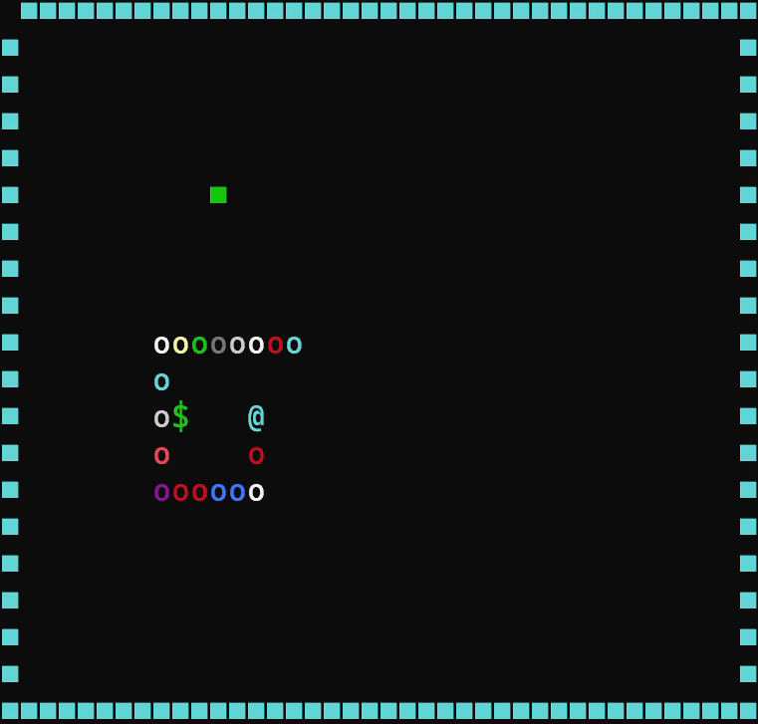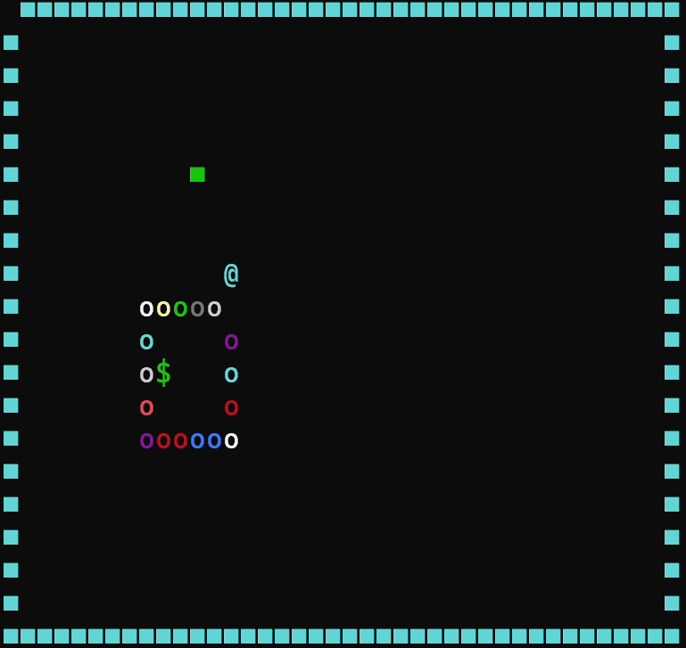

/*判断是否碰到蛇身*/
int Overlap(){
//int t = snake.length;
for (int i = 1; i < snake.length; i++) { //判断蛇头是否和蛇身重叠，重叠表示自撞
if (snake.snakeNode[0].x == snake.snakeNode[i].x && snake.snakeNode[0].y == snake.snakeNode[i].y){
// //表示存在重叠，需要断尾
// for (int j = i+1; i < t; j++){
// GotoXY(snake.snakeNode[j].x ,snake.snakeNode[j].y);
// printf(" ");
// snake.length-=1;
return i;}
}
return 0;
}
并且，在MoveSnake（）函数中增加以下代码：
//判断是否自撞
if(Overlap()){
int t = snake.length;
for (int j = Overlap()+1; j < t; j++){
GotoXY(snake.snakeNode[j].x ,snake.snakeNode[j].y);
printf(" ");
snake.length-=1;
}
GotoXY(50, 5);
printf("当前得分: %d ", snake.length - 3); //打印得分，得分为蛇长减原始长度3
}

在地图内增加障碍物，如果碰到障碍物，蛇也会死亡。
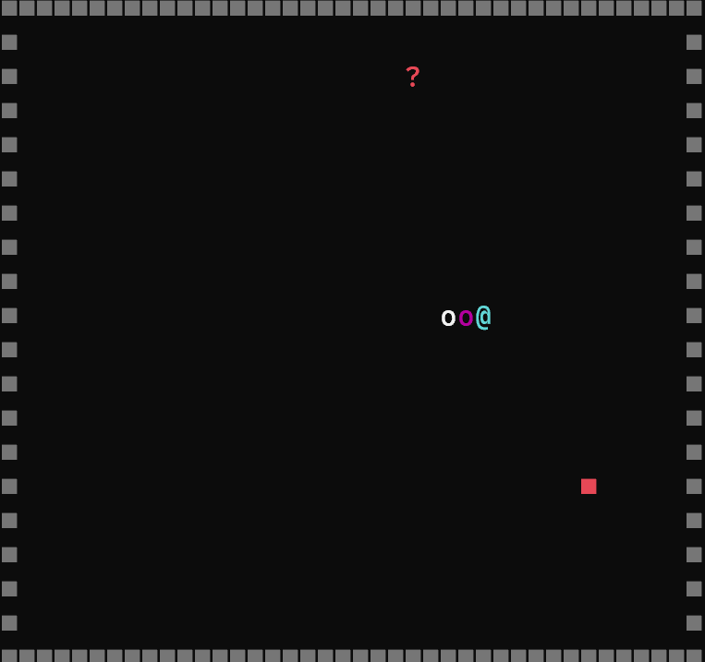

/*生成障碍物函数*/
void PrintBarrier() {
int flag = 1;
while (flag) {
flag = 0;
//设置随机的障碍物坐标位置
barrier.x = rand() % (MAP_WIDTH - 2) + 1;
barrier.y = rand() % (MAP_HEIGHT - 2) + 1;
//循环判断障碍物位置是否和蛇的位置重叠，如果重叠则需要重新设置食物位置
for (int k = 0; k <= snake.length - 1; k++) {
if (snake.snakeNode[k].x == barrier.x && snake.snakeNode[k].y == barrier.y&&food.x == barrier.x && food.y == barrier.y) {
flag = 1; //位置有重叠，需要继续循环
break;
}
}
if (barrier.x == 0 || barrier.y == 0 || barrier.x == MAP_HEIGHT || barrier.y == MAP_WIDTH) {
flag = 1;
}
}
GotoXY(barrier.x, barrier.y);
printf("■");
}

增加多种食物选项，蛇的生长速度取决于吃到的食物。
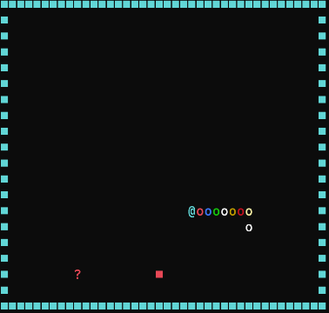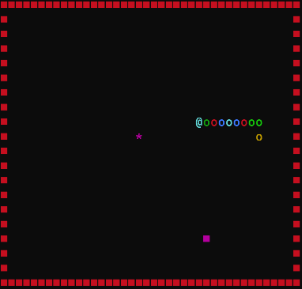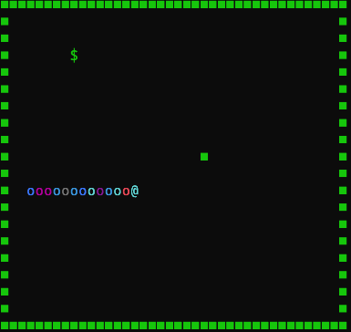

/*生成食物函数*/
void PrintFood() {
int flag = 1;
while (flag) {
flag = 0; //假设本次生成的事物有效
//设置随机的食物坐标位置
food.x = rand() % (MAP_WIDTH - 2) + 1;
food.y = rand() % (MAP_HEIGHT - 2) + 1;
//循环判断食物位置是否和蛇的位置重叠，如果重叠则需要重新设置食物位置
for (int k = 0; k <= snake.length - 1; k++) {
if (snake.snakeNode[k].x == food.x && snake.snakeNode[k].y == food.y) {
flag = 1; //位置有重叠，需要继续循环，将本次生成设为无效，重新生成
break;
}
}
if (food.x == 0 || food.y == 0 || food.x == MAP_HEIGHT || food.y == MAP_WIDTH) {
flag = 1; //食物位置与边框位置存在重合
}
}
GotoXY(food.x, food.y);
int nb = rand() % 3; //选择随机生成的食物
if (nb == 0 ) {
unknown_food = 1;
SetColor(13);
printf("*"); //普通食物
} else if (nb == 1) {
unknown_food = 2;
SetColor(10);
printf("$"); //精华食物
} else if (nb == 2) {
int sb = rand()%10+1;
if (sb == 1) {
unknown_food = 0;
} else if (sb >= 2 && sb <= 7) {
unknown_food = 3;
} else {
unknown_food = -1;
}
SetColor(12);
printf("?"); //未知的食物
}
}

增加积分排行榜功能，按历次游戏积分排名。
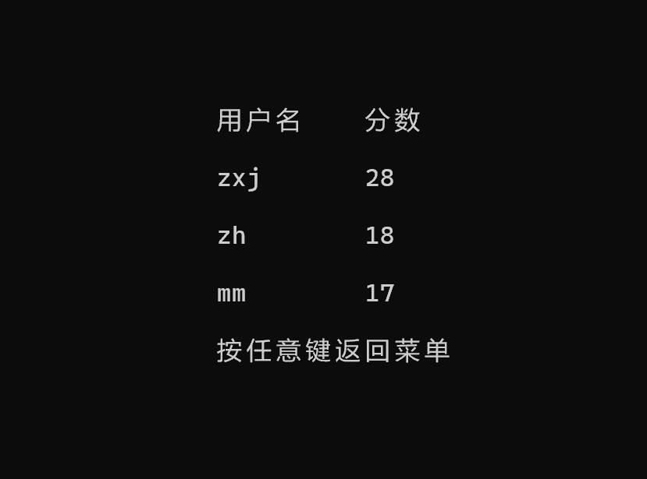

/*积分榜函数*/
void Read() {
FILE *file;
file = fopen("scores.txt", "rb");
fscanf(file, "%d", &data[0].count);
for (int i = 0; i < data[0].count; i++) {
fscanf(file, "%s", &data[i].name);
fscanf(file, "%d", &data[i].score);
data[i].count = data[0].count;
}
fclose(file);
}

void List() {
GotoXY(48, 12);
printf("用户名");
GotoXY(58, 12);
printf("分数");
int i;
for (i = 0; i < data[0].count; i++) {
GotoXY(48, 12 + (i + 1) * 2);
printf("%s", data[i].name);
GotoXY(58, 12 + (i + 1) * 2);
printf("%d", data[i].score);
}
GotoXY(48, 12 + (i + 1) * 2);
printf("按任意键返回菜单");
Hide();
char ch = _getch();
system("cls");
}

void Name() {
GotoXY(48, 12);
printf("请输入用户名：");
GotoXY(48, 14);
scanf("%s", &data[data[0].count].name);
data[0].count++;
char ch = _getch();
system("cls");
}

void Rank() {
int max_index;
char a[50];

for (int i = 0; i < data[0].count; i++) {
max_index = i;
for (int j = i + 1; j < data[0].count; j++) {
if (data[j].score > data[i].score) {
max_index = j;
}
}
strcpy(a, data[i].name);
strcpy(data[i].name, data[max_index].name);
strcpy(data[max_index].name, a);
int temp = data[i].score;
data[i].score = data[max_index].score;
data[max_index].score = temp;

}
List();
}

void Write() {
FILE *file;
file = fopen("scores.txt", "wb");
fprintf(file, "%d\n", data[0].count);
for (int i = 0; i < data[0].count; i++) {
fprintf(file, "%s ", data[i].name);
fprintf(file, "%d", data[i].score);
fprintf(file, "\n");
}
fclose(file);
}

5、创新点、创新措施列举
（1）蛇运动过程中颜色会发生变化，不同的障碍物有不同的颜色
设计思路：生成的过程中，进行SetColor操作，并且随机生成颜色
代码：①SetColor(rand()%14+2); //随机设置颜色
printf("o"); //打印蛇身
②GotoXY(food.x, food.y);
int nb = rand() % 3; //选择随机生成的食物
if (nb == 0 ) {
unknown_food = 1;
SetColor(13);
printf("*"); //普通食物
} else if (nb == 1) {
unknown_food = 2;
SetColor(10);
printf("$"); //精华食物
} else if (nb == 2) {
int sb = rand()%10+1;
if (sb == 1) {
unknown_food = 0;
} else if (sb >= 2 && sb <= 7) {
unknown_food = 3;
} else {
unknown_food = -1;
}
SetColor(12);
printf("?"); //未知的食物
}

- 吃到食物以后，边框颜色有可能发生改变
设计思路：每次吃到食物，对边框进行重置
代码：//没吃到食物时，在原来的蛇尾打印一个空格，去掉原来的蛇尾
if (!flag) {
GotoXY(temp.x, temp.y);
printf(" ");
} else {
GotoXY(barrier.x,barrier.y);
printf(" "); //吃到食物，则需要在地图上重新更新一个食物
PrintFood();
PrintBarrier();
SetColor(rand()%10+2); //吃到食物，则随机改变边框颜色
for (int i = 0; i < MAP_WIDTH; i++) {
GotoXY(i, 0);
printf("■");
GotoXY(i, MAP_HEIGHT - 1);
printf("■");
}
//生成地图左右边界
for (int i = 0; i < MAP_HEIGHT - 1; i++) {
GotoXY(0, i);
printf("■");
GotoXY(MAP_WIDTH - 1, i);
printf("■");
}
- 增加q和e键，进行加减速
设计思路：类比方向键的获取，增加全局变量x进行速度调整（设置两个速度函数，分别对应快速和慢速）
代码：
snake.h 里
#define Speedup 'q' //定义加速键
#define Speeddown 'e' //定义减速键
snake.c 里（在最前面定义全局变量int x=2；）
//响应键盘修改
if (_kbhit()) { //键盘输入返回1，非键盘输入返回0
direction = _getch();
switch (direction) { //因为每次只有一个键盘输入，所以和方向输入放一起了
case Speedup:x = 1; break; //速度修改
case Speeddown:x = 2; break;
default:break;
}
在判断死亡条件后加入
if (x == 1) {
SpeedControl1();//快速
GotoXY(50,15);
printf(" 当前速度：快速 ");
}
else {
SpeedControl2();//慢速
GotoXY(50,15);
printf(" 当前速度：慢速 ");
}

- 增加单人双人模式
int Player_Mode()
{
SetConsoleOutputCP(936);
GotoXY(40, 12); // 定位光标位置
printf("选择玩家模式");
GotoXY(43, 14);
printf("1.单人模式");
GotoXY(43, 16);
printf("2.双人模式");

char ch;
int result = 0;
ch = _getch(); // 接收用户输入的菜单选项
switch (ch)
{
case '1':
result = 1;
break;

case '2':
result = 2;
break;
}
system("cls");
return result;
}
int Enable_AI()
{
SetConsoleOutputCP(936);
GotoXY(40, 12); // 定位光标位置
printf("选择是否启用AI");
GotoXY(43, 14);
printf("1.启用AI");
GotoXY(43, 16);
printf("2.不启用AI");

char ch;
int result = 0;
ch = _getch(); // 接收用户输入的菜单选项
switch (ch)
{
case '1':
result = 1;
break;

case '2':
result = 2;
break;
}
system("cls");
return result;
}

